|  |  |
| --- | --- |
| Project | Database Practice Using SQL |
| Name | Md. Zobayer Ibna Kabir |
| Date | 28.05.2024 |

**• Create Database:**

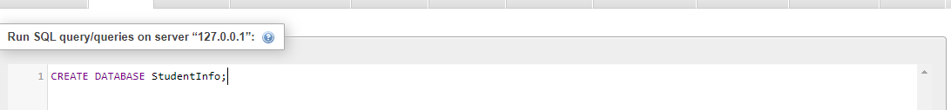

**• Create TABLE:**

Two tables were created to perform a join operation.

* StudentInfo
* UniversityInfo

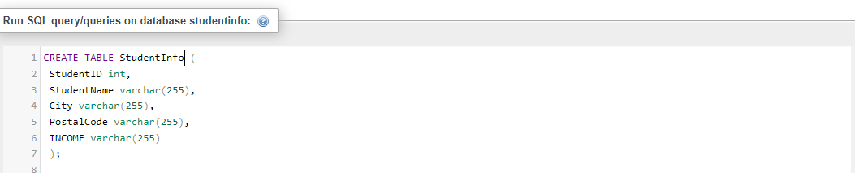

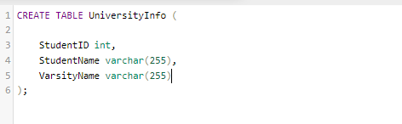

**• INSERT VALUE in Table:**

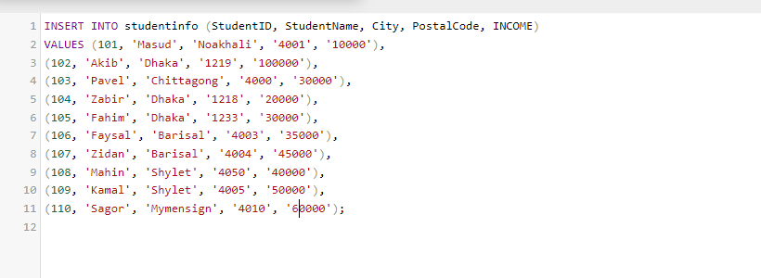

**• ALTER TABLE:**

Three new columns were added to the existing table using the ALTER TABLE statement.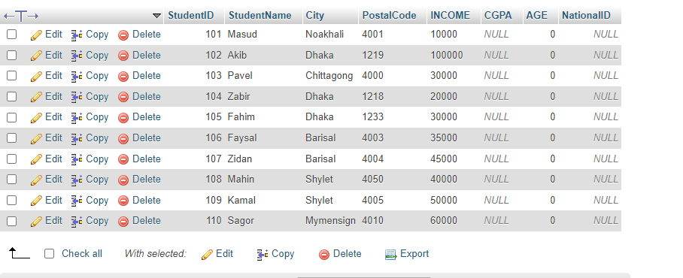

New values were inserted into the three newly added columns after their creation.

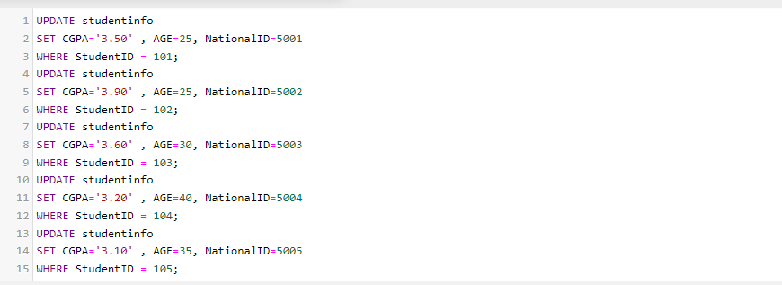

**QUERYING DATA FROM SINGLE TABLE**

**SELECT statement is used to select data from a database**

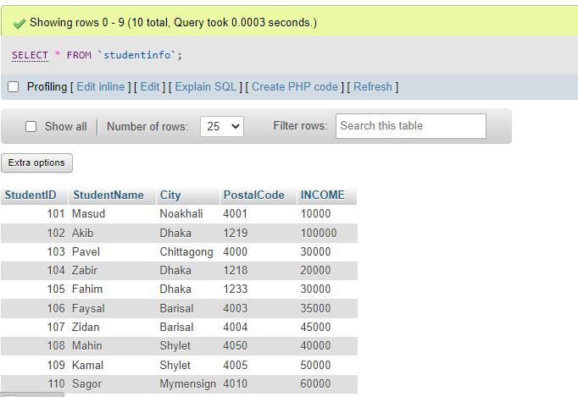

**SELECT DISTINCT statement is used to return only distinct (different) values*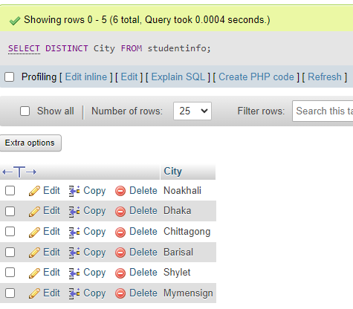***

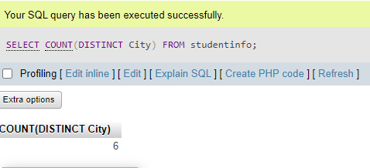

**WHERE clause is used to filter records**

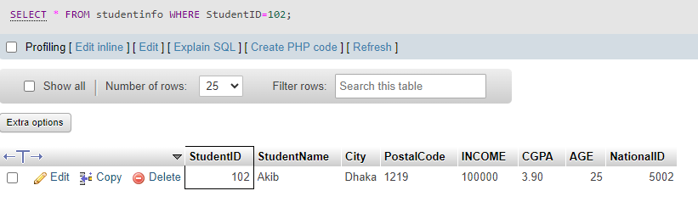

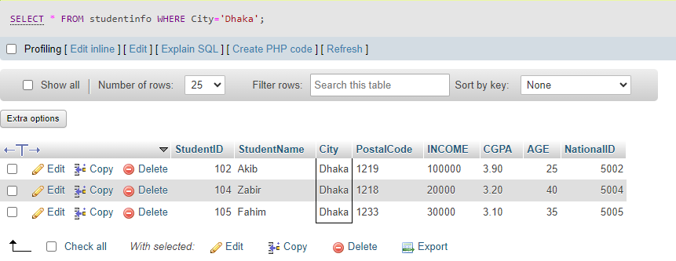

**WHERE clause can be combined with AND, OR, and NOT operators**

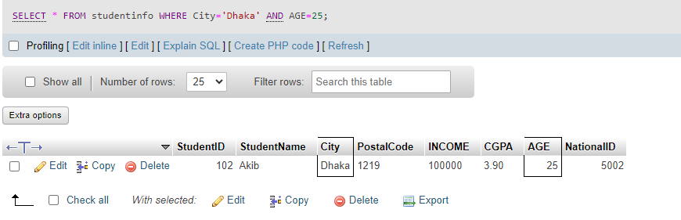

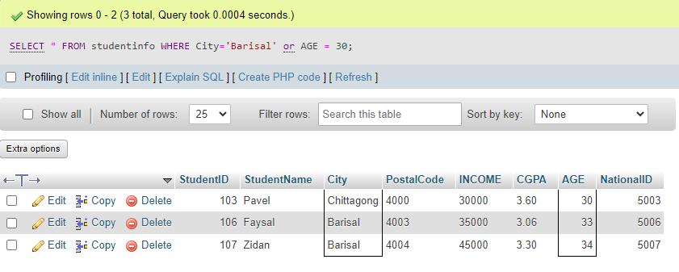

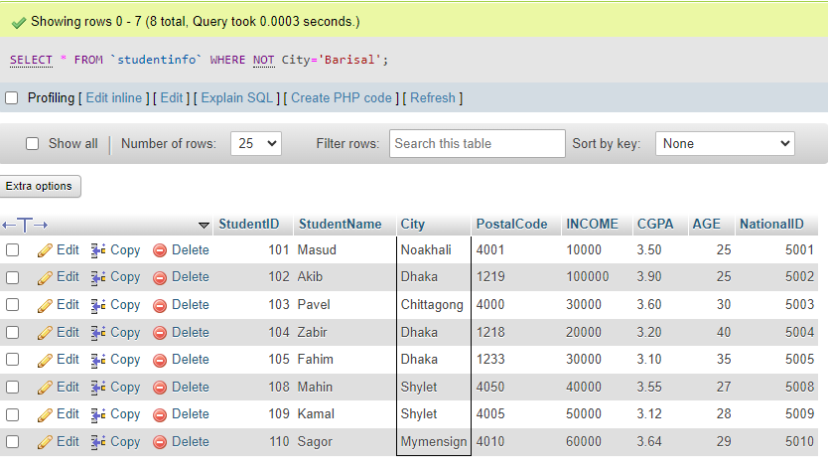

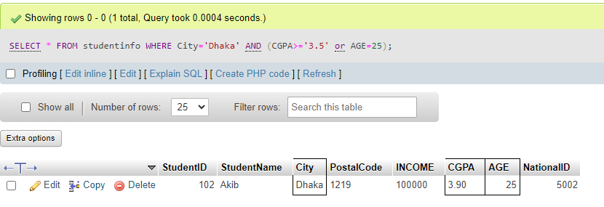

**ORDER BY keyword is used to sort the result-set in ascending or descending order**

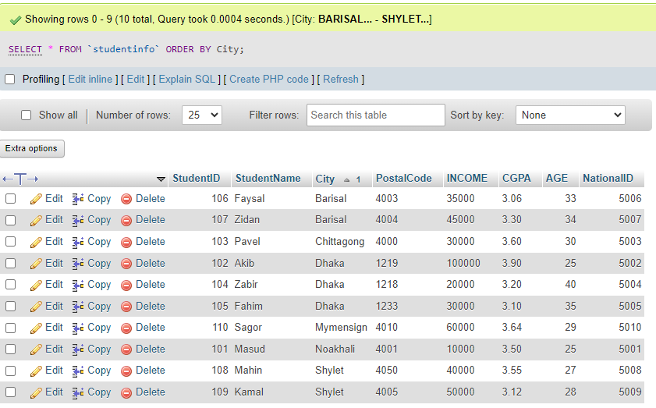

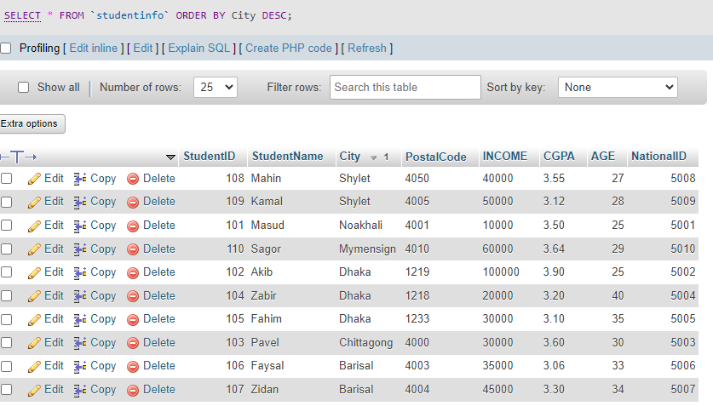

**UPDATE statement is used to modify the existing records in a table**

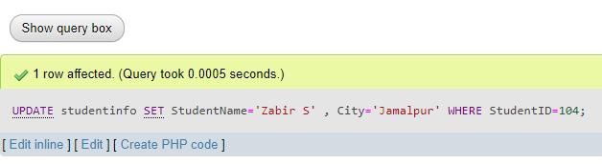



**DELETE statement is used to delete existing records in a table**

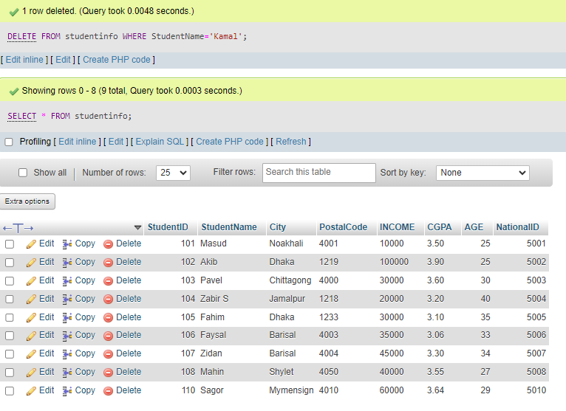

**BETWEEN operator selects values within a given range**

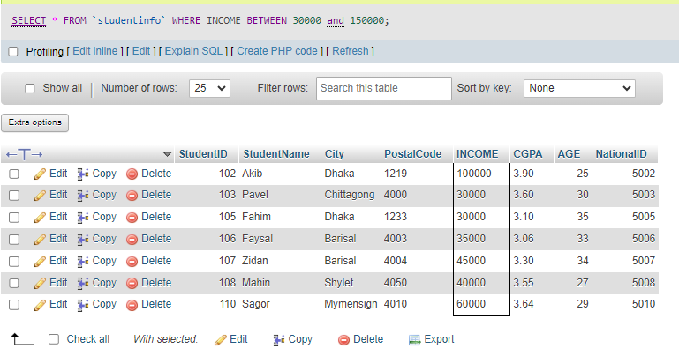

**MIN() and MAX() function returns the smallest & largest value**

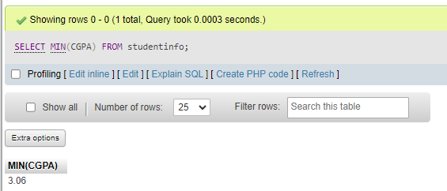

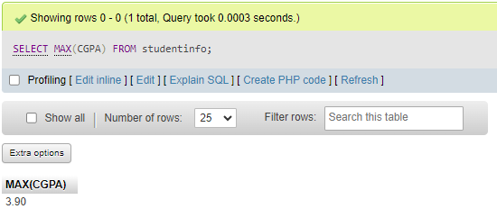

**INNRER JOIN**

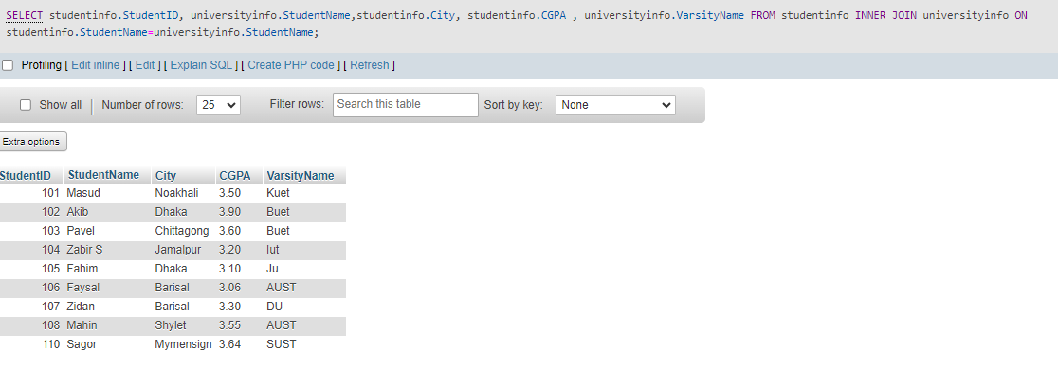

**LEFT JOIN**

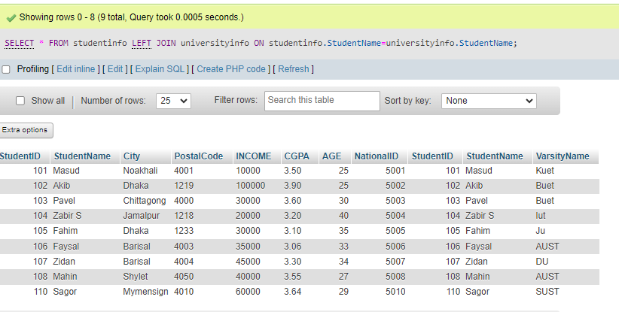

**RIGHT JOIN**

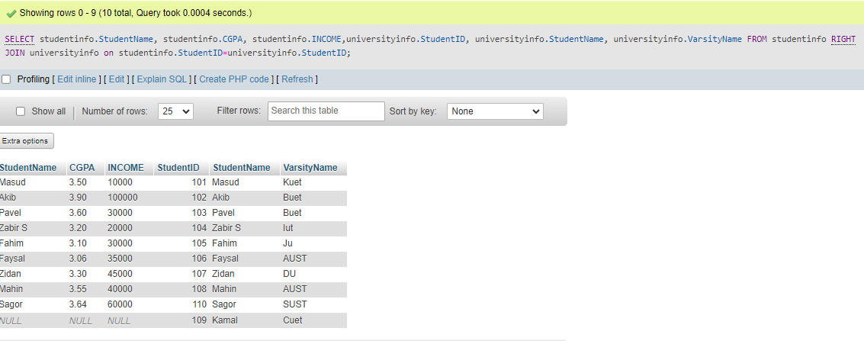

**FULL OUTER JOIN**

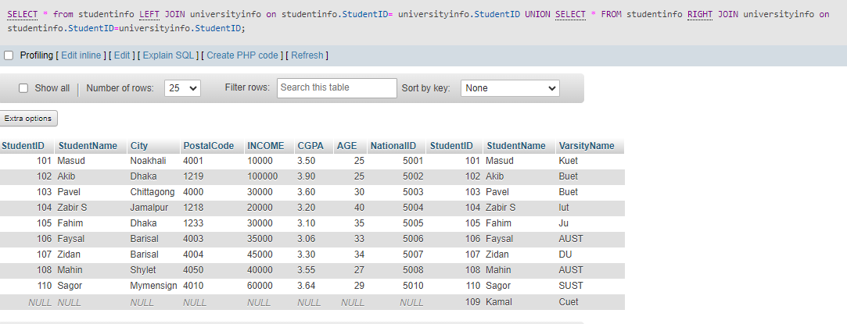

**Cross Join:**

